# ­­­Lab 1: Environment Setup – Getting Started

In this exercise, you will:

* Install Git
* Install Node.js
* Install Google Chrome
* Install Code Editor Visual Studio Code(open source)/WebStorm(paid)
* Install Electron

Note: These instructions will get your system up and running for Electron development.

## Install Git

1. Visit <https://git-scm.com/downloads>
2. Download and run the installer for your OS.
3. Confirm that Git is installed properly by listing the version number.

git --version

## Install Node.js

### For Mac

1. Run the Homebrew installer in a terminal window:

/usr/bin/ruby -e "$(curl -fsSL https://raw.githubusercontent.com/Homebrew/install/master/install)"

Note: This will install Node.js as part of the install.

1. Confirm your Node.js version number:

node -v

### For Windows:

1. Visit <http://nodejs.org>
2. Download the latest LTS version for Windows.
3. Install the .msi package
4. Confirm your Node.js version number:

node -v

## Install Google Chrome

1. Visit the http://google.ca/ in your browser and download Chrome.

## Install Visual Studio Code

1. Visit https://code.visualstudio.com/docs/setup/setup-overview and go to Downloads section and download.

Note: This step will help you set up Visual Studio Code for your system based on OS you are currently using.

1. Start Visual Studio Code and open the Extensions viewlet (Ctrl + Shft + X).
2. Search for and install the *Debugger for Chrome* extension.

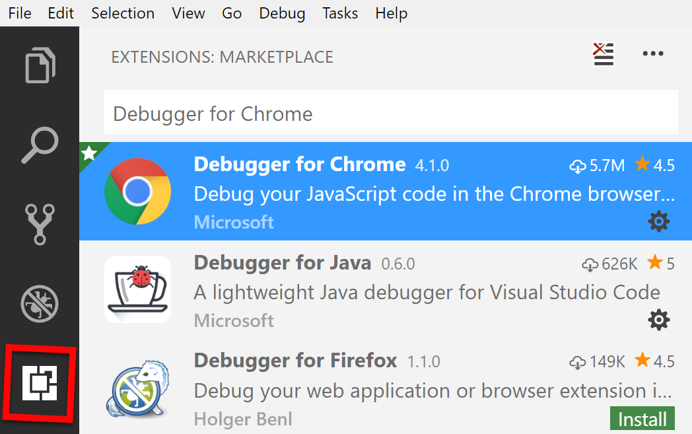

Note: After the extension is finished installing, you will be prompted to restart the program.

## Install Electron

1. Open up a new terminal and type below command.

npm install –g electron

## Install the sample app – Electron Bootcamp

1. In your command line, navigate to the root of your <course-files> folder.
2. Use the following git commands to clone the sample app.

git clone https://github.com/DEV6hub/Electron-Bootcamp

cd Electron-Bootcamp

git status

Note: You should see that your branch is up to date with origin master.

1. Install the dependencies that are defined in the project's package.json file.

npm install

1. Start the json-server for serving rest api’s from within your project. Open a new terminal window and navigate to JSON Server folder and run below command.

json-server --watch signup.json

Note: This command will spin up a restful server on default port 3000. You can also verify it by visiting URL <http://localhost:3000/userInfo> in your browser.

1. Similarly, navigate to your project and then JSON Server. Open up new terminal window for each of the below commands. It will spin rest of the api’s up and running.

json-server --watch tshirts.json --port 4000

json-server –watch contactUs.json –port 5000

Note: Verify these URL’s in your browser <http://localhost:4000/tshirts> and <http://localhost:5000/contactUs>.

1. Start the app.

npm run start

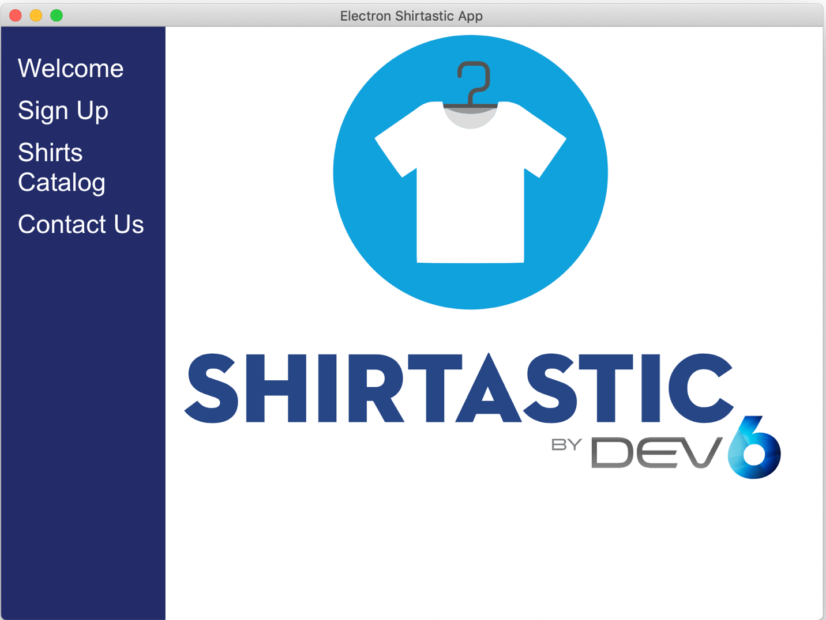

Note: Familiarize with Shirtastic App. Play around, click side navigation links and verify all the links are working fine for you.